Medical Store: Inventory Management and Supplier Information System

Project Report submitted in the Partial Fulfilment
of
Bachelor of Technology (Integrated)
In
Information Technology

by

SAP ID | Roll No. | Name
70372100030 | F005 | MEET M. PANCHAL
70372100004 | F030 | MAYUR H. DOSHI
70372100057 | F034 | YASH D. VYAS

Under the supervision of

Dr. Bhisaji Surve

(Assistant Professor, Information, MPSTME)

2023-24
CERTIFICATE

This is to certify that the project entitled MEDICAL STORE: INVENTORY MANAGEMENT AND SUPPLIER INFORMATION SYSTEM, has been done by MR. MEET M. PANCHAL, MR. MAYUR H. DOSHI AND MR. YASH D. VYAS under my guidance and supervision & has been submitted in partial fulfilment of the degree of BACHELOR IN TECHNOLOGY (INTEGRATED) in INFORMATION TECHNOLOGY of MPSTME, SVKM’s NMIMS (Deemed-to-be University), Mumbai, India.

Project Mentor (Name and Signature) Examiner ( name and Signature)
(Internal Guide)
Date

Place: Mumbai (HoD) (name and Signature)

ACKNOWLEDGEMENT

SAP ID | Roll No. | Name
70372100030 | F005 | MEET M. PANCHAL
70372100004 | F030 | MAYUR H. DOSHI
70372100057 | F034 | YASH D. VYAS

ABSTRACT
In today's dynamic world of managing inventory and supplier information, there's a growing demand for a solution that seamlessly integrates both aspects while being user-friendly. This project aims to tackle the intricacies and hurdles posed by current software by introducing a web-based platform designed for simplicity and ease of use. The main objective is to offer vital functionalities for inventory management, supplier information tracking, and order processing all within a single, intuitive interface.

Problem Definition:
The existing "Medical Shop Inventory and Supplier Management Systems" encounter obstacles such as ineffective inventory monitoring, reliance on manual procedures, and a deficiency in real-time updates. These issues contribute to operational hindrances, heightened inaccuracies, and less-than-ideal utilization of resources, ultimately affecting the overall quality of customer service.

Proposed Work:
Our proposed project endeavours to redefine the user experience in handling inventory, supplier details, and order information. The website is structured around two core components: the Inventory Management System and the Supplier Information System. This setup enables users to seamlessly navigate and search for medicines based on various criteria, enhancing efficiency and user satisfaction.

Within the Inventory Management System, medicines can be easily located
using identifiers such as ID, name, MRP, location, composition, packaging, category, company ID, and supplier ID. Similarly, the Supplier Information System allows searches by supplier name or ID, alongside additional details like contact number, address, and email.

To facilitate efficient management, dedicated webpages are introduced for inventory database management and order viewing. The Manage webpage offers functionalities for modifying, adding, and deleting entities within the database. Additionally, the Order webpage enables users to view orders, reorder items, or adjust order contents as needed. Moreover, it integrates features for generating invoices, thereby enhancing the overall utility of the website.

In summary, our project aims to simplify and streamline inventory management, supplier information retrieval, and order processing. By prioritizing a user-friendly interface and incorporating essential functionalities, we seek to overcome the limitations of existing software solutions, ensuring accessibility even for users with limited technical expertise.

TABLE OF CONTENTS
Nº. | Particulars | Page Nº.
1 | Chapter 1: INTRODUCTION | 3
 | 1.1: BACKGROUND
 | 1.2: PROBLEM STATEMENT
 | 1.3: OBJECTIVES
 | 1.4: ORGANIZATION OF THE REPORT
2 | Chapter 2: MARKET SURVEY | 4
 | 2.1: ANALYSIS OF CURRENT SOFTWARES
 | 2.2: INSIGHTS AND FINDINGS
3 | Chapter 3: METHODOLOGY & EXECUTION | 4
 | 3.1: DATABASE STRUCTURING
 | 3.2: BACKEND SCREENSHOTS
 | 3.3: FLOW OF THE WEBSITE
 | 3.4: FRONTEND SCREENSHOTS
4 | Chapter 4: RESULT | 4
 | 4.1: FINAL RESULTS
5 | Chapter 5: ADVANTAGES, LIMITATIONS, & APPLICATIONS | 4
 | 5.1: ADVANTAGES
 | 5.2: LIMITATIONS
 | 5.3: APPLICATIONS
6 | CONCLUSION AND FUTURE SCOPE | 6
7 | REFERENCES | 8
Chapter 1: INTRODUCTION
1.1: BACKGROUND
In the realm of retail pharmacy, efficient inventory management and effective supplier coordination stand as crucial pillars for operational excellence. However, many traditional medical stores find themselves entangled in manual and outdated procedures, resulting in challenges with stock control and supplier handling.

This project emerges amidst these prevalent challenges, with a goal to revolutionize how medical stores manage their inventory and suppliers. Beyond mere stock oversight, the project introduces a comprehensive supplier management system, aiming to elevate the entire supply chain process.

Within the retail pharmacy sector, the absence of integrated supplier management systems often leads to disjointed communication, delayed orders, and less-than-ideal pricing agreements. Manual methods of order placement, delivery tracking, and contract management can result in missed opportunities for cost efficiency and service enhancement.

Acknowledging these hurdles, the project is dedicated to tackling both inventory and supplier management aspects. Through the implementation of a user-friendly website that seamlessly merges inventory control with supplier management functionalities, the project aims to optimize the medicine procurement process as a whole.

Furthermore, this initiative aligns with broader industry trends towards digital transformation and supply chain enhancement. As retail pharmacies increasingly embrace digital solutions to stay competitive, the necessity for comprehensive inventory and supplier management systems becomes increasingly evident.
1.2: PROBLEM STATEMENT
The current "Medical Shop Inventory and Supplier Management System" faces challenges with inefficient inventory tracking, manual processes, and a lack of real-time updates. This results in operational bottlenecks, increased errors, and suboptimal resource utilization, impacting overall customer experience. To address these issues, a comprehensive solution is needed for streamlined inventory management, enhanced order processing, and real-time stock level insights within a user-friendly framework.

1.3: OBJECTIVES
Our project's primary objectives are meticulously crafted to tackle the multifaceted challenges encountered by medical stores in managing inventory and information systems. By establishing clear goals, we aim to achieve tangible outcomes that enhance operational efficiency and elevate overall performance.

- Comprehensive Shop Operations Solution: We aim to provide a holistic solution covering all essential operations of medical stores, including inventory management, information systems, billing, and order processing. Our goal is to streamline workflows and centralize operations to improve efficiency and convenience for store owners.

- Improved User Experience: Our focus is on designing a user-friendly interface that requires minimal knowledge and skills to navigate effectively. We prioritize usability and accessibility to facilitate seamless interactions and enhance overall satisfaction with the system.

- Optimized Inventory Management: We're developing a robust inventory management system to help medical stores optimize stock levels effectively. This includes real-time inventory tracking, automated stock replenishment, and predictive analytics to prevent stockouts and overstocking situations.

- Streamlined Information Systems: Our aim is to implement a comprehensive information system to streamline operations. This involves digitizing processes, facilitating seamless communication, and centralizing information for easy access and evaluation.

- Comprehensive Search Functionality: We're enabling comprehensive search functionality in the inventory, allowing users to quickly locate specific items based on various criteria such as name, ID, price, quantity, packaging, company, and composition.

- Enhanced Order Accuracy and Timeliness: We're automating order placement and processing to improve accuracy and timeliness. Our goal is to minimize manual intervention and errors in the ordering process, ensuring timely replenishment of stock and minimizing supply disruptions.

By aligning with these objectives, our project aims to deliver a comprehensive solution addressing the specific pain points of medical stores while fostering efficiency, transparency, and innovation in inventory management and information systems.
1.4: ORGANIZATION OF THE REPORT
The structure of this report has been meticulously organized to offer a thorough understanding of the project's scope, methodology, and implications. Each chapter has been strategically crafted to build upon the previous one, presenting a logical progression of information and insights. Here's a breakdown of the report's organization:

- Chapter 1: Introduction
  - 1.1 Background: This section provides context by delving into the project's background, explaining its rationale and motivations.
  - 1.2 Problem Statement: It identifies and articulates the specific challenges addressed by the project, emphasizing the need for intervention and innovation.
  - 1.3 Objectives: This part outlines the overarching goals of the project, detailing the desired outcomes and targets.
  - 1.4 Organization of the Report: This current section gives an overview of the report's structure, guiding the reader through subsequent chapters and sections.

- Chapter 2: Market Survey
  - 2.1 Analysis of Current Softwares: This segment presents a detailed analysis of existing inventory management practices and challenges in the market.
  - 2.2 Insights and Findings: It offers insights gleaned from market research and surveys, highlighting key findings and trends.

- Chapter 3: Methodology & Implementation
  - 3.1 Database Structuring: This section explores the architecture and design of the database system implemented in the project.
  - 3.2 Backend Screenshots: This segment offers insights into backend functionalities and processes, highlighting system functionality and performance.
  - 3.3 Flow of the Website: It describes the user flow and interface design of the website, illustrating user interactions.
  - 3.4 Frontend Screenshots: Here, we present screenshots and visual representations of the frontend interface, showcasing user experience and design elements.

- Chapter 4: Results and Analysis
  - 4.1 Final Results: Implementation successful.

- Chapter 5: Advantages, Limitations, & Applications
  - 5.1 Advantages: Enumerates the benefits conferred by the project, outlining its positive impacts on stakeholders and end-users.
  - 5.2 Limitations: This section acknowledges constraints and limitations, addressing areas for improvement.
  - 5.3 Applications: Explores potential extensions of the project beyond its current scope, identifying areas for future growth.

- Chapter 6: Conclusion and Future Scope
- This chapter concludes the report by summarizing key findings, insights, and implications drawn from the project. It also discusses potential avenues for future research, development, and enhancement.

- Chapter 7: References
- Provides a comprehensive list of all sources cited throughout the report, ensuring transparency and accountability in research and analysis.
Chapter 2: MARKET SURVEY
2.1: ANALYSIS OF CURRENT SOFTWARES
During our market survey, we visited two medical stores to evaluate their software usage and operational challenges. Our observations revealed that both establishments faced difficulties with their respective software solutions.

At the first store, "Samartha Software" was found to be overly complex and challenging to operate efficiently. Similarly, the software used at the second store, "Touro," presented similar usability issues, hampering smooth day-to-day operations. In both cases, the software lacked features optimized for the specific needs of the medical retail sector, resulting in redundant functionalities and suboptimal performance.

A significant finding was the absence of robust order management capabilities in both software solutions. Surprisingly, despite this limitation, the first store managed orders manually through communication platforms like WhatsApp. Meanwhile, the second store attempted to compensate for the software's deficiencies by using additional applications such as Retailio and PharmaRack. However, these supplementary tools failed to offer comprehensive order management functionality, leading to inefficiencies and inconsistencies in the store's operations.

The prevalence of manual methods and fragmented software solutions underscores the challenges inherent in managing medical retail operations manually. These experiences emphasize the urgent need for a streamlined, user-friendly, and feature-rich software solution tailored specifically to the unique requirements of medical retail establishments.
2.1: INSIGHTS AND FINDINGS
During our market survey of medical stores, we gained valuable insights into the software solutions in use and the operational challenges these establishments face. Here are the key findings from our observations:

- Complexity of Existing Software: The software utilized by both medical stores we visited, namely "Samartha Software" and "Touro," proved to be overly complex and difficult to navigate efficiently. Store personnel found the interfaces cluttered, and accessing various features was daunting.

- Limited Functionality: Despite their complexity, the existing software solutions offered limited functionality, particularly in managing orders and inventory. Tasks like order processing and tracking were challenging, leading to operational inefficiencies.

- Dependency on Manual Methods: Interestingly, one of the stores relied on manual methods such as WhatsApp for order management due to software inadequacies. This manual approach increased the risk of errors and introduced delays and inconsistencies in order handling.

- Supplementary Apps: One of the medical stores had integrated supplementary apps like Retailio and PharmaRack. However, these apps only partially addressed operational challenges and did not provide a comprehensive solution for order management and inventory control.

- Difficulty in Manual Management: Overall, our findings underscored the challenges of manually managing operations in medical stores, particularly without robust software support. Manual methods were labour-intensive, error-prone, and lacked the efficiency needed in a modern healthcare environment.

In conclusion, our insights emphasize the urgent need for user-friendly and feature-rich software solutions tailored to the specific requirements of medical stores. Addressing the operational challenges identified in our survey is essential for enhancing efficiency, streamlining processes, and ensuring optimal service delivery in the medical store sector.
Chapter 3: METHODOLOGY & EXECUTION
3.1: DATABASE STRUCTURE
The database structure is established using MySQL, managed through XAMPP, a popular open-source cross-platform web server solution stack package developed by Apache Friends. Here's a breakdown of the database structure:
- Company Table (company):
  - Contains information about pharmaceutical companies.
  - Fields include company_id, c_name, c_address, and c_phoneNo.
- Inventory Table (inventory):
  - Stores data related to the available stock of medicines.
  - Includes fields such as inventory_id, medicine_id, and quantity.
  - The medicine_id field establishes a relationship with the Medicine table.
- Medicine Table (medicine):
  - Holds details about various medicines.
  - Fields consist of medicine_id, m_name, m_mrp, m_composition, m_packaging, m_location, and company_id.
  - The company_id field links to the Company table, specifying the manufacturer.
- Order Items Table (order_items):
  - Records individual items within orders.
  - Attributes cover order_items_id, quantity, medicine_id, and order_id.
  - The medicine_id and order_id fields establish relationships with the Medicine and Supplier Order tables, respectively.
- Supplier Table (supplier):
  - Contains information regarding suppliers.
  - Fields include supplier_id, s_name, s_phoneNo, s_address, and s_mail.
- Supplier Order Table (sup_order):
  - Manages supplier orders.
  - Contains order_id, o_date, delivery_date, order_status, and supplier_id.
  - The supplier_id field links to the Supplier table.
The database is designed to facilitate efficient management of medicines, suppliers, and orders within the system, ensuring seamless operations and effective inventory control.

Entity - Relationship Diagram
Schema Diagram
Cardinality:
- Company : Medicine – 1 : n
- Medicine : Order Items – 1 : 1
- Order : Order Items – 1 : n
- Supplier : Order – 1 : n
- Medicine : Inventory – 1 : 1

3.2: BACKEND SCREENSHOTS

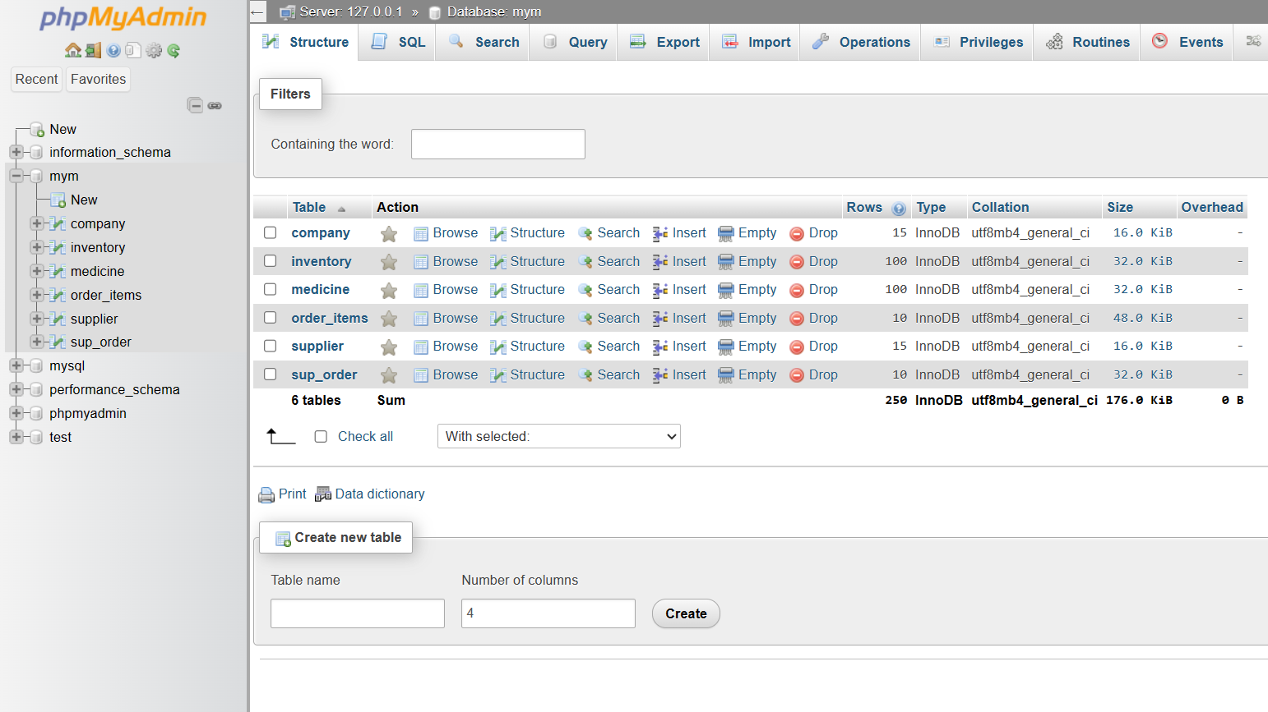

Fig 3.3.1: Database schema showing all tables in the MYM schema.

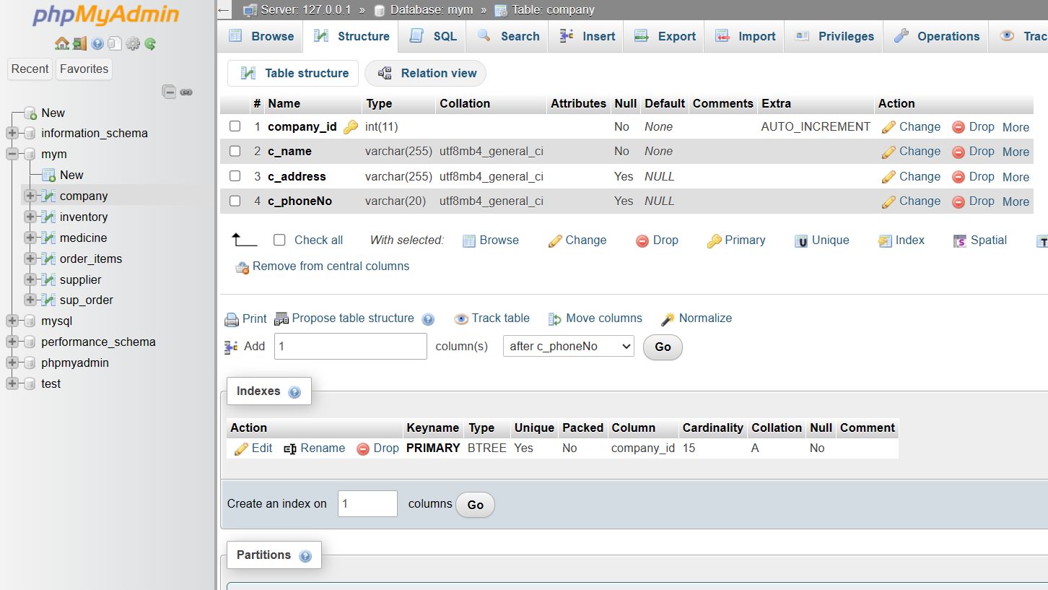

Fig 3.3.2: Structure of the Company table.

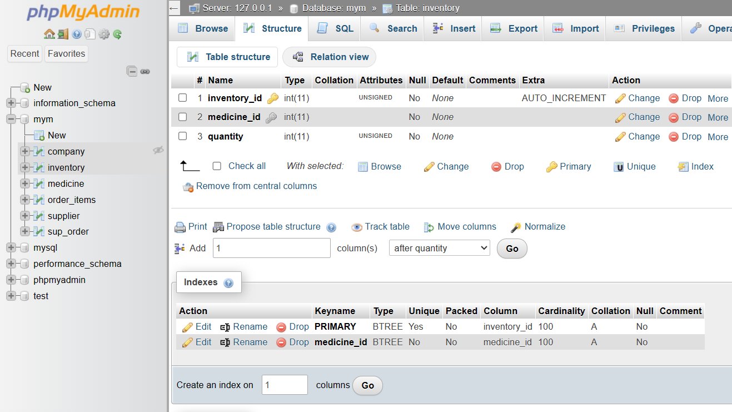

Fig 3.3.3: Structure of the Inventory table.

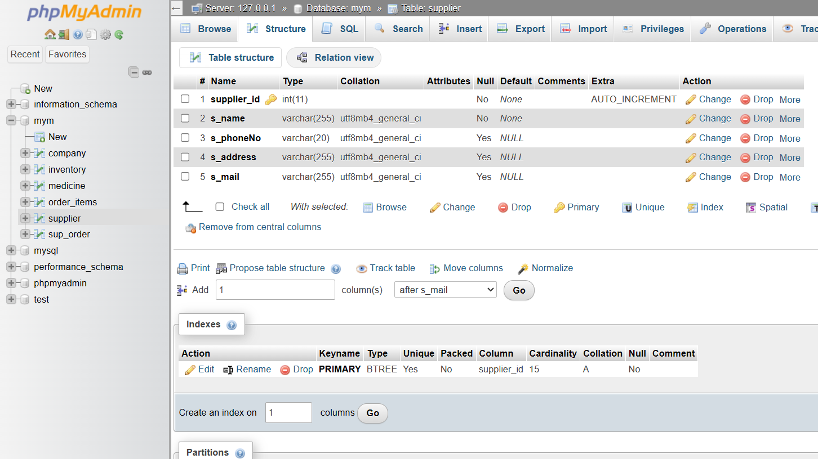

Fig 3.3.4: Structure of the Supplier table.

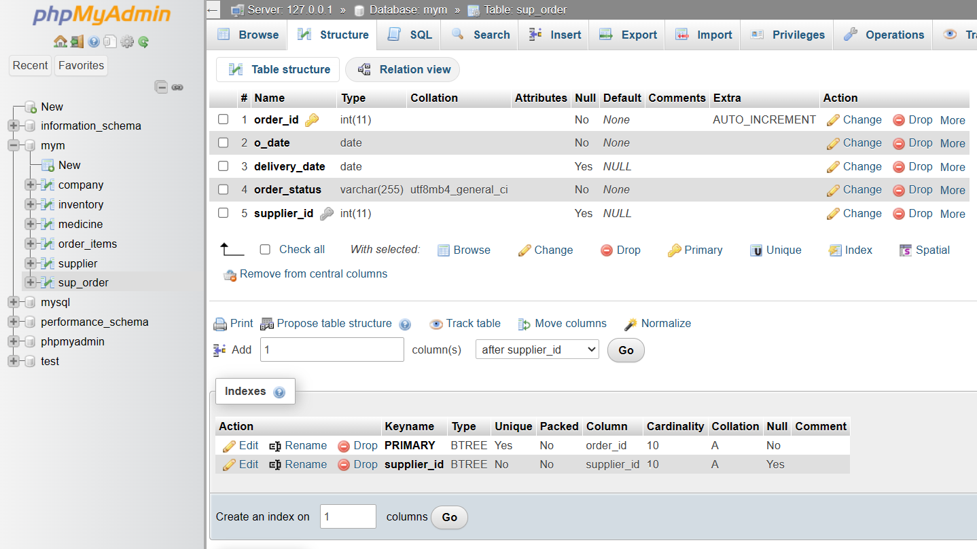

Fig 3.3.5 Structure of the Supplier Order table.

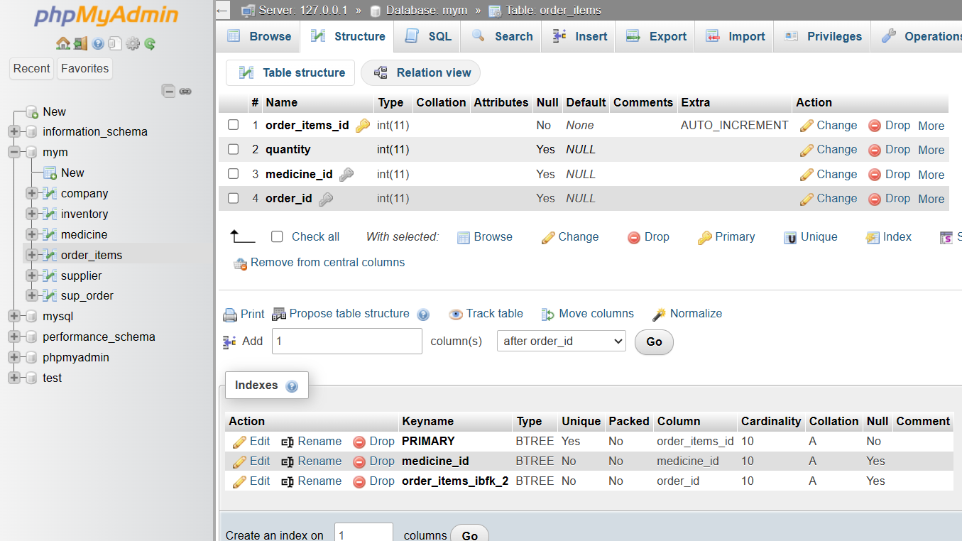

Fig 3.3.6: Structure of the Order Items table.

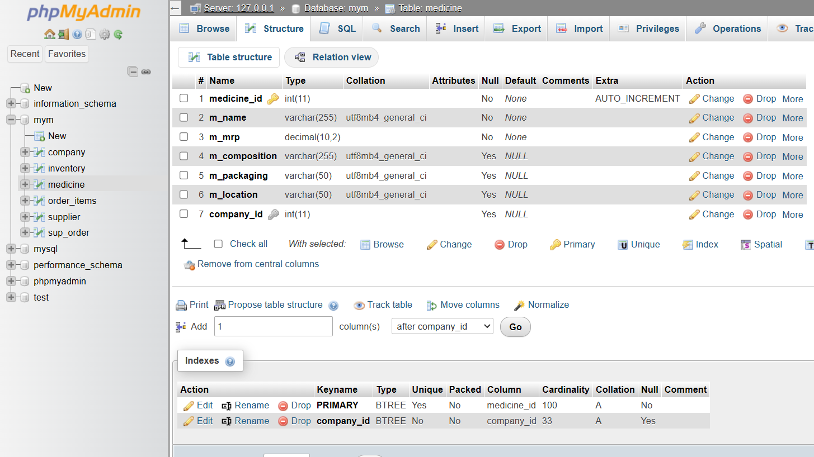

Fig 3.3.7: Structure of the Medicine table.

3.3: FLOW & IMPLEMENTATION DETAILS
- User Login:
  - Users log in to access the website.
- Dashboard:
  - Users are greeted with alerts for medicines under the threshold value, ensuring they stay informed about stock levels.
  - The dashboard displays a bar chart illustrating the quantity of medicines under the threshold, providing a visual representation of inventory status.
  - A miniature of the inventory table gives users a quick overview of their stock.
  - Supplier details and order details are also accessible from the dashboard for easy management.
- Database:
  - This section provides access to various management functionalities, including managing medicines, suppliers, and company details.
  - Users can add, delete, or modify medicines, companies and suppliers as needed to maintain an updated database.
- Inventory:
  - Users can view the current inventory status, including medicine names, quantities, prices, and other relevant details.
  - The inventory section allows users to search and sort based on any field, except for the last ordered field.
  - The quantity in the inventory is automatically updated according to the billing and ordering system, ensuring accurate stock management.
- Bill:
  - Users can generate bills for purchases made by customers, recording transactions accurately.
  - Although users cannot download bills directly from the website, they can view and print bills for record-keeping purposes.
- Order:
  - In this section, users can view all orders placed with suppliers, track order status, and manage deliveries.
  - Users can also punch CSV files received from suppliers to update the order information seamlessly.
- Supplier:
  - Users can manage supplier details, including contact information, addresses, and other relevant data.
  - This section facilitates smooth communication and collaboration with suppliers to ensure efficient procurement processes.
3.4: FRONTEND SCREENSHOTS



Fig 3.4.1 User Login.

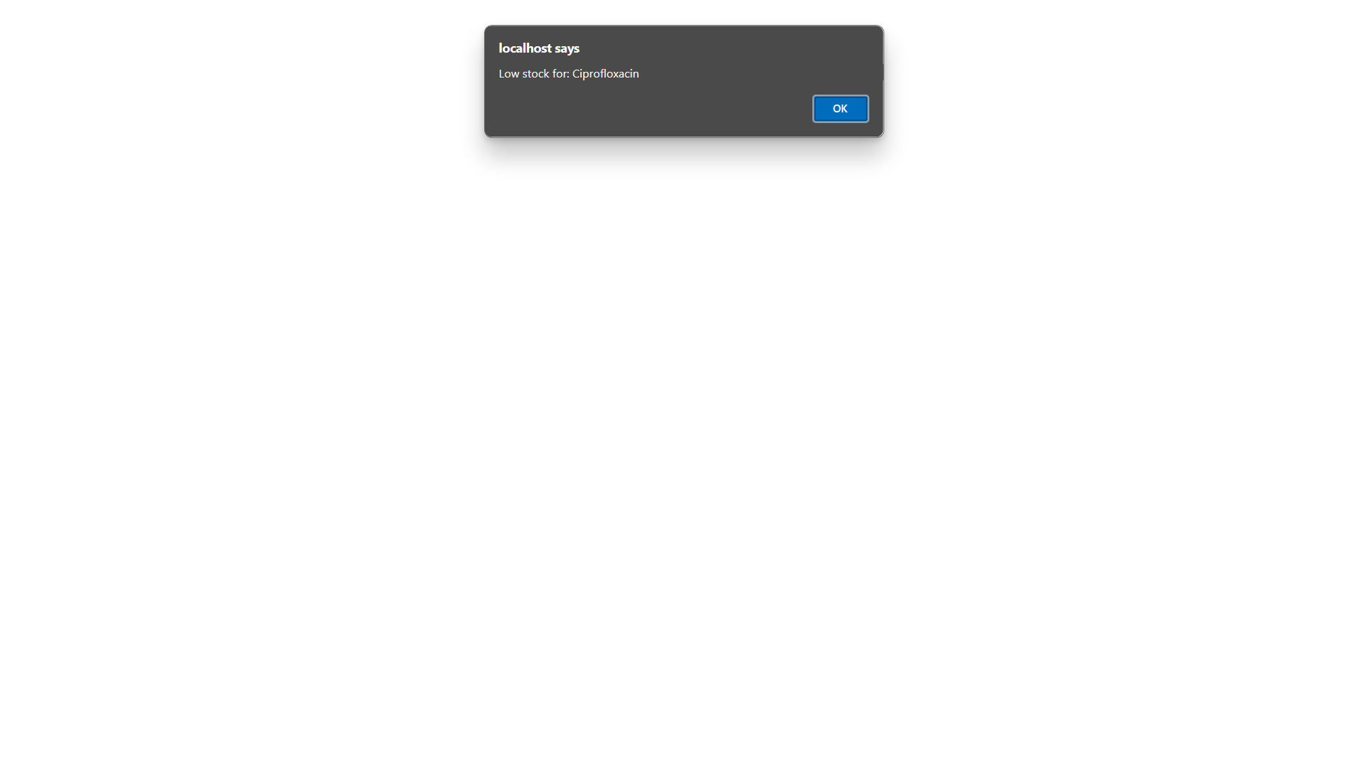

Fig 3.4.2 Alerts for medicines under the Threshold Quantity (if any).

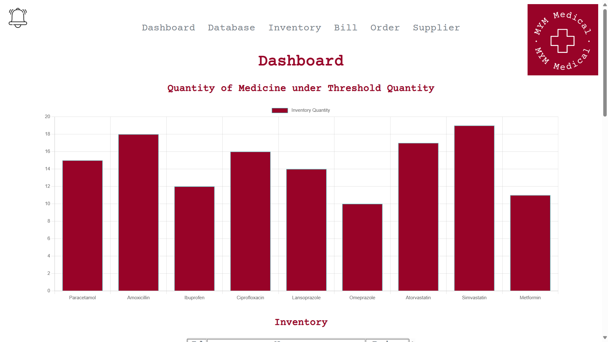

Fig 3.4.3.1 Dashboard – Bar chart for medicine quantity under the Threshold Quantity.

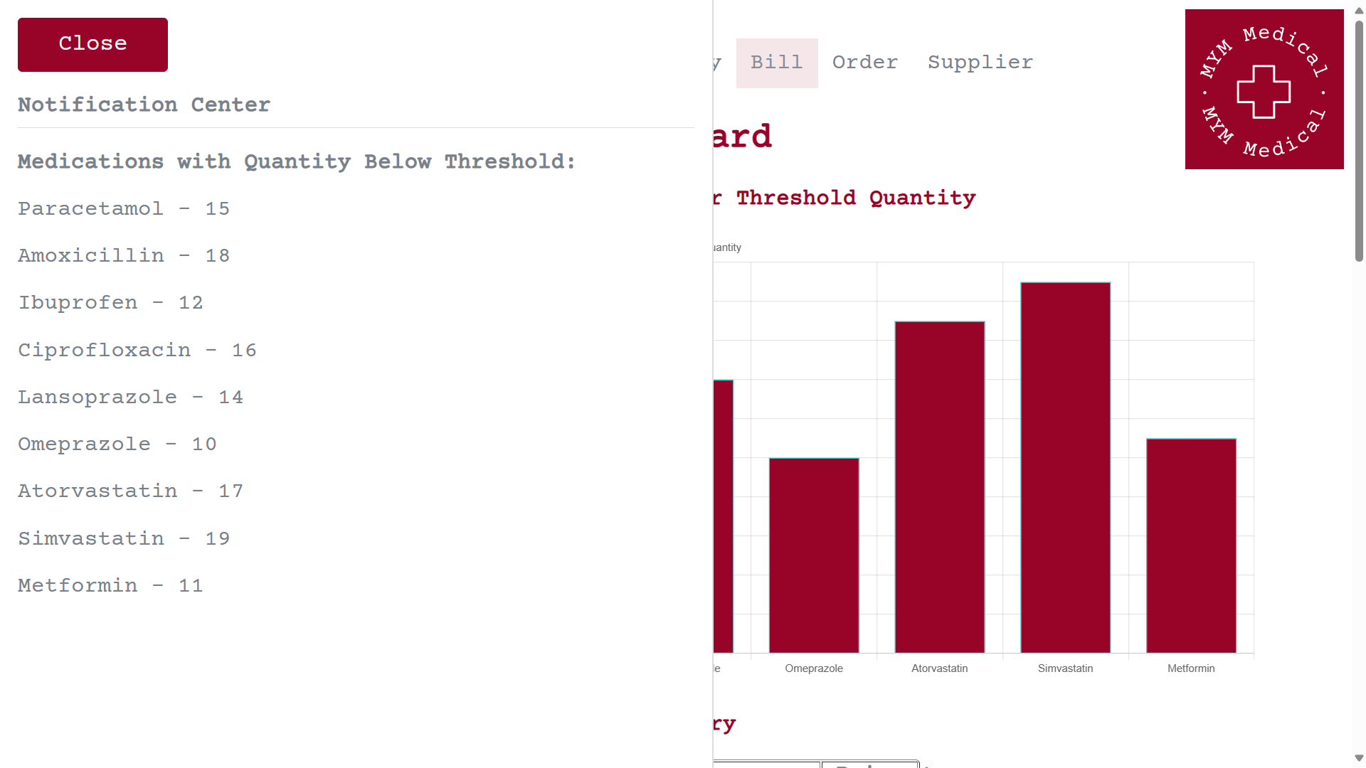

Fig 3.4.3.2 Dashboard – Notification center.

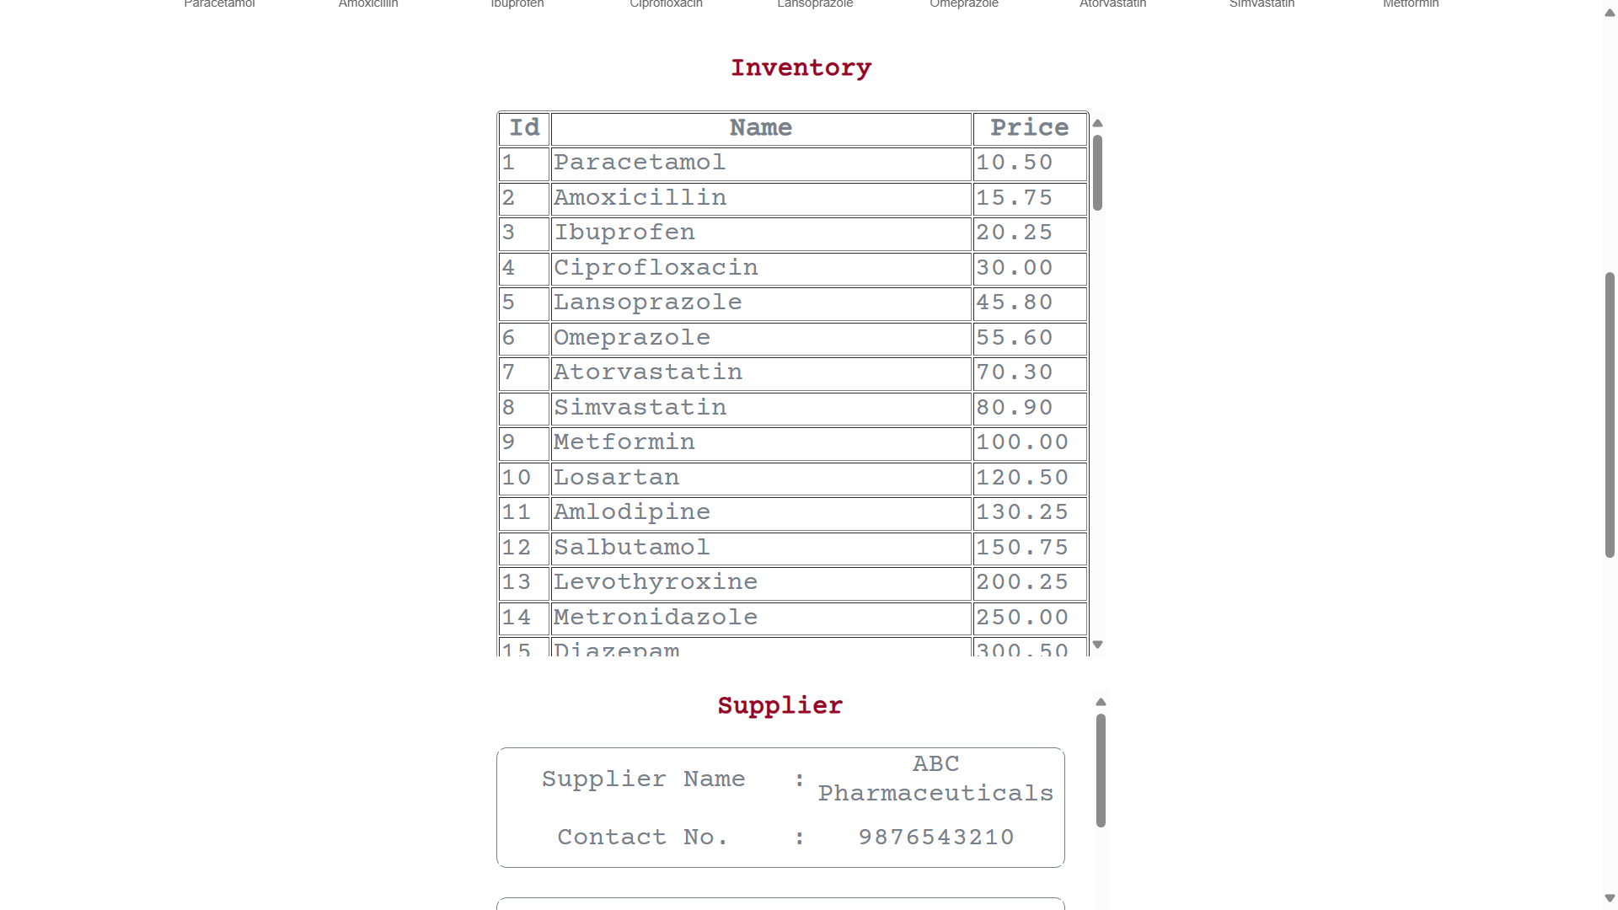

Fig 3.4.3.3 Dashboard – Overview of Inventory.

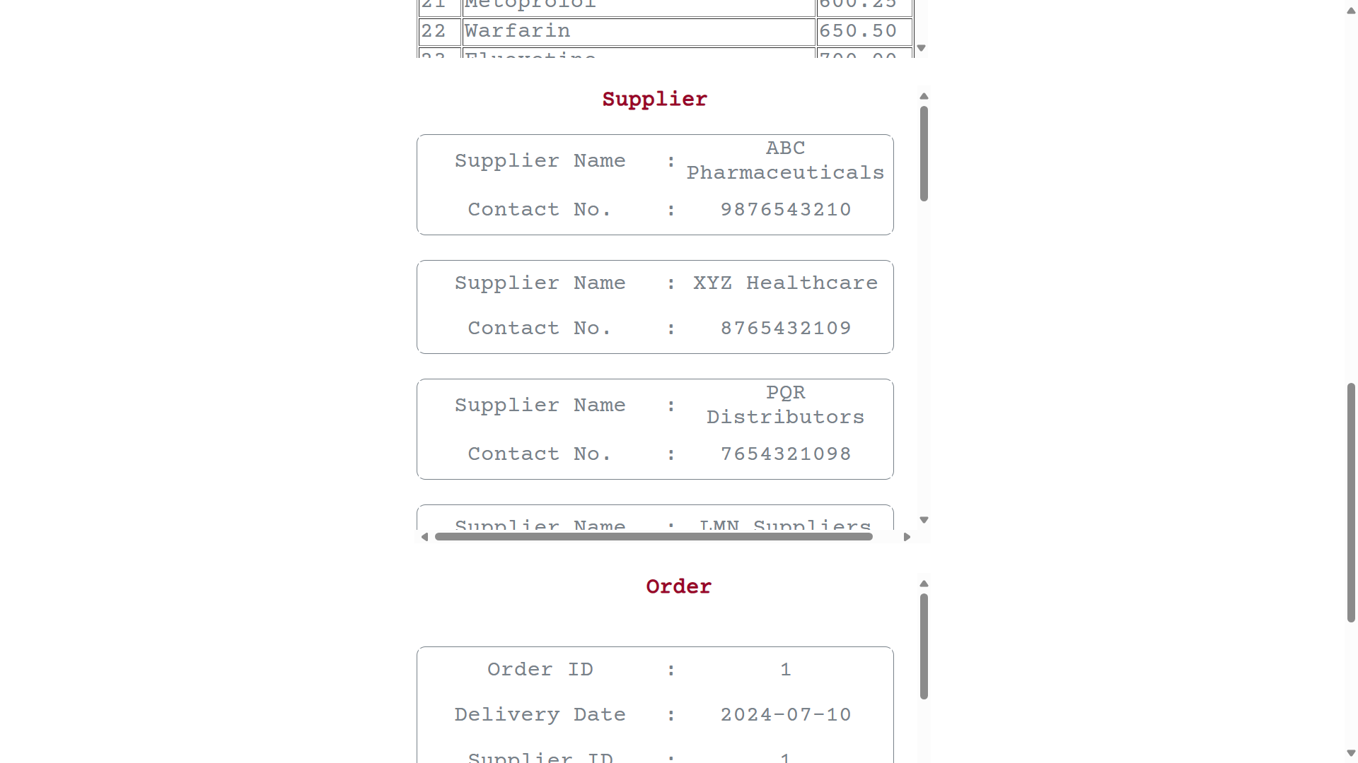

Fig 3.4.3.4 Dashboard – Overview of Supplier Information.

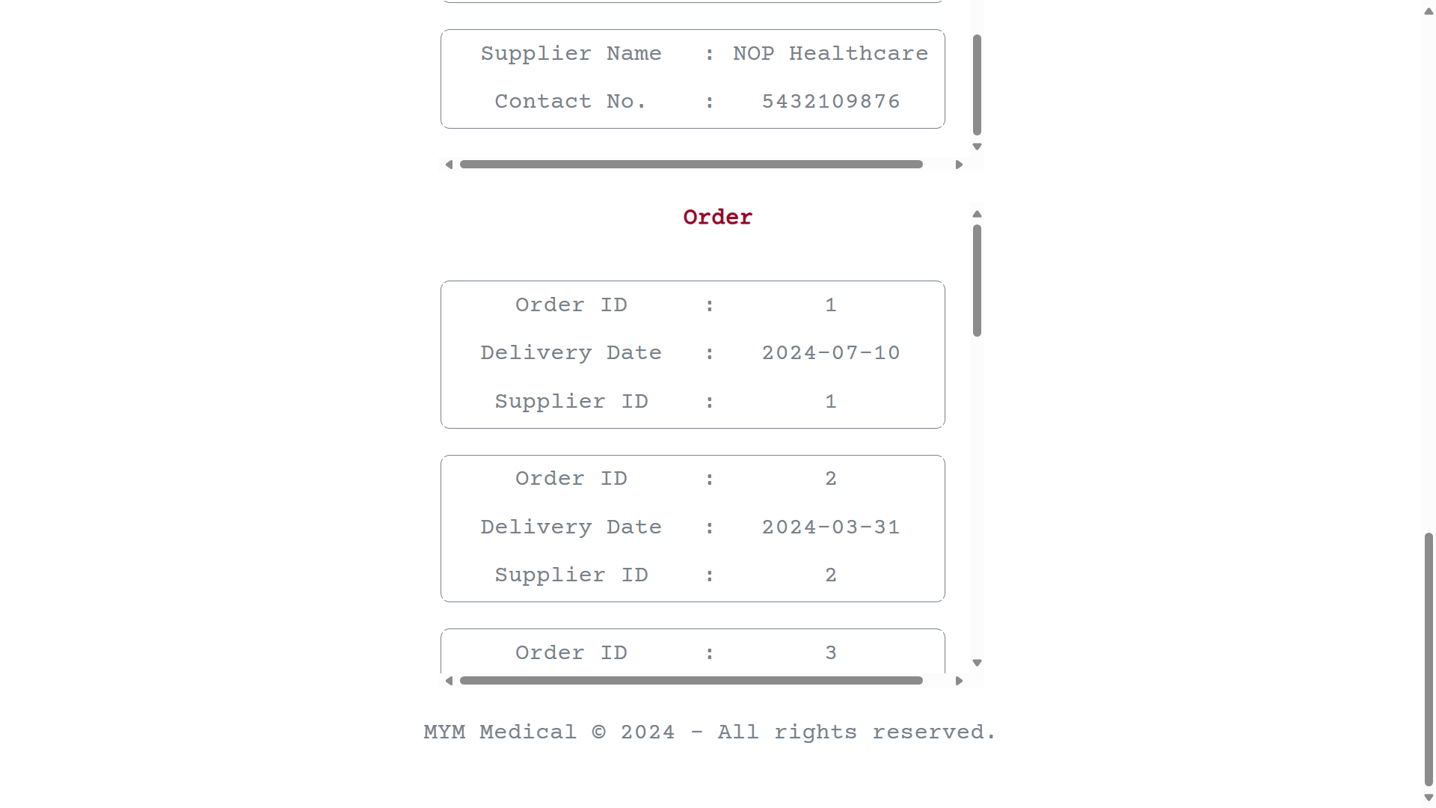

Fig 3.4.3.3 Dashboard – Overview of Order Information.

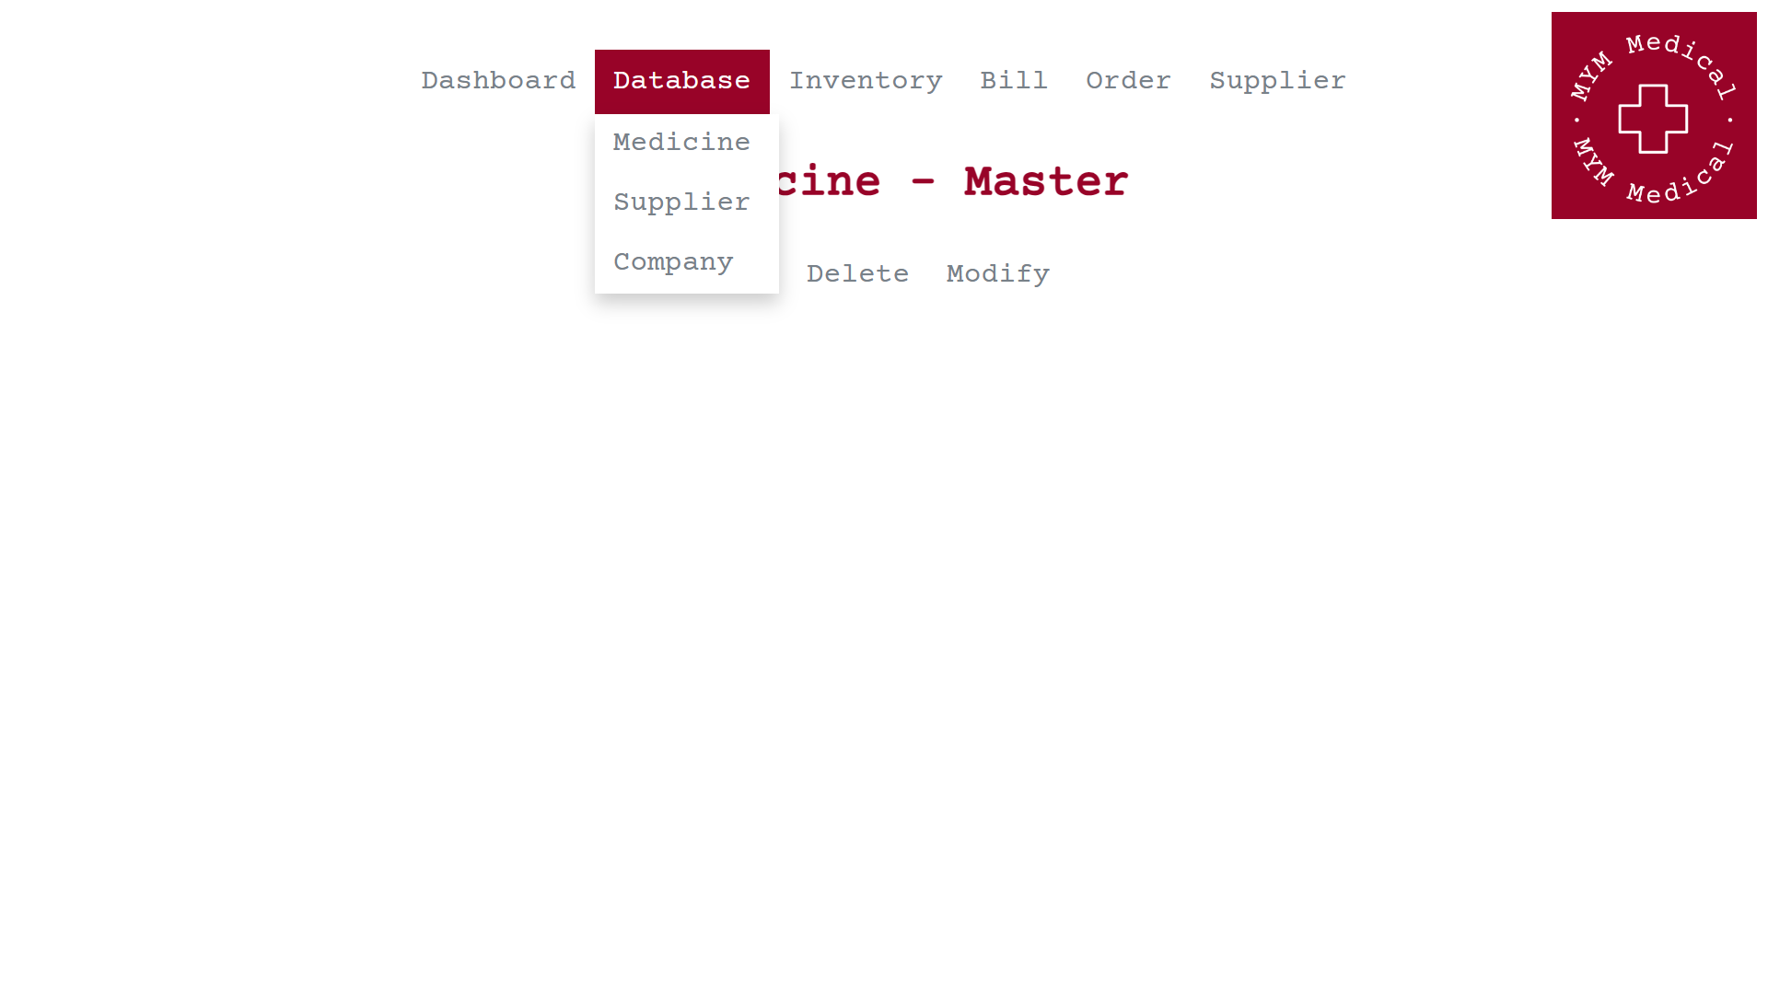

Fig 3.4.4 Database management through GUI.

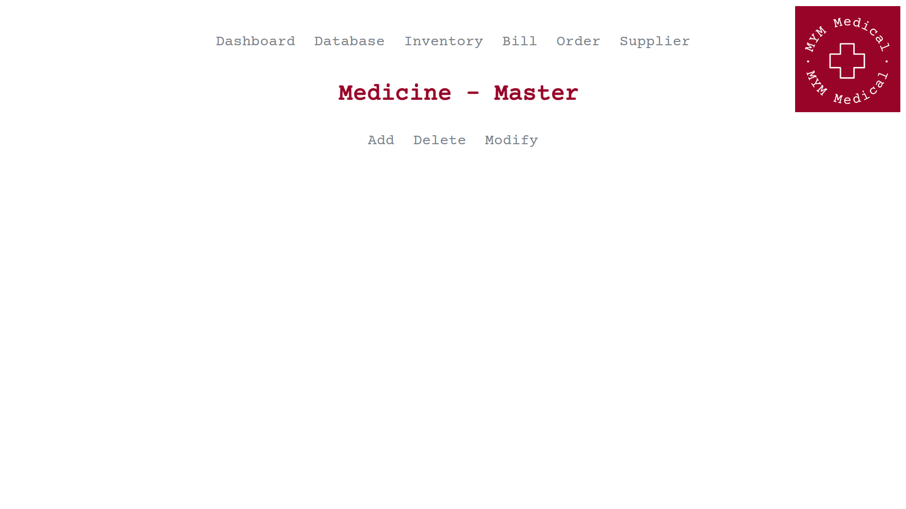

Fig 3.4.4.1 Medicine’s master.

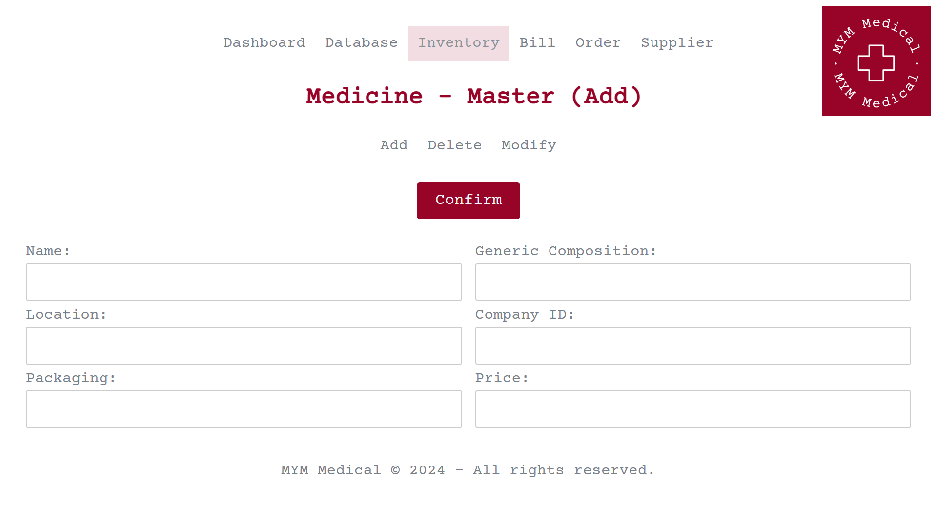

Fig 3.4.4.1.1 Form to add a new medicine.

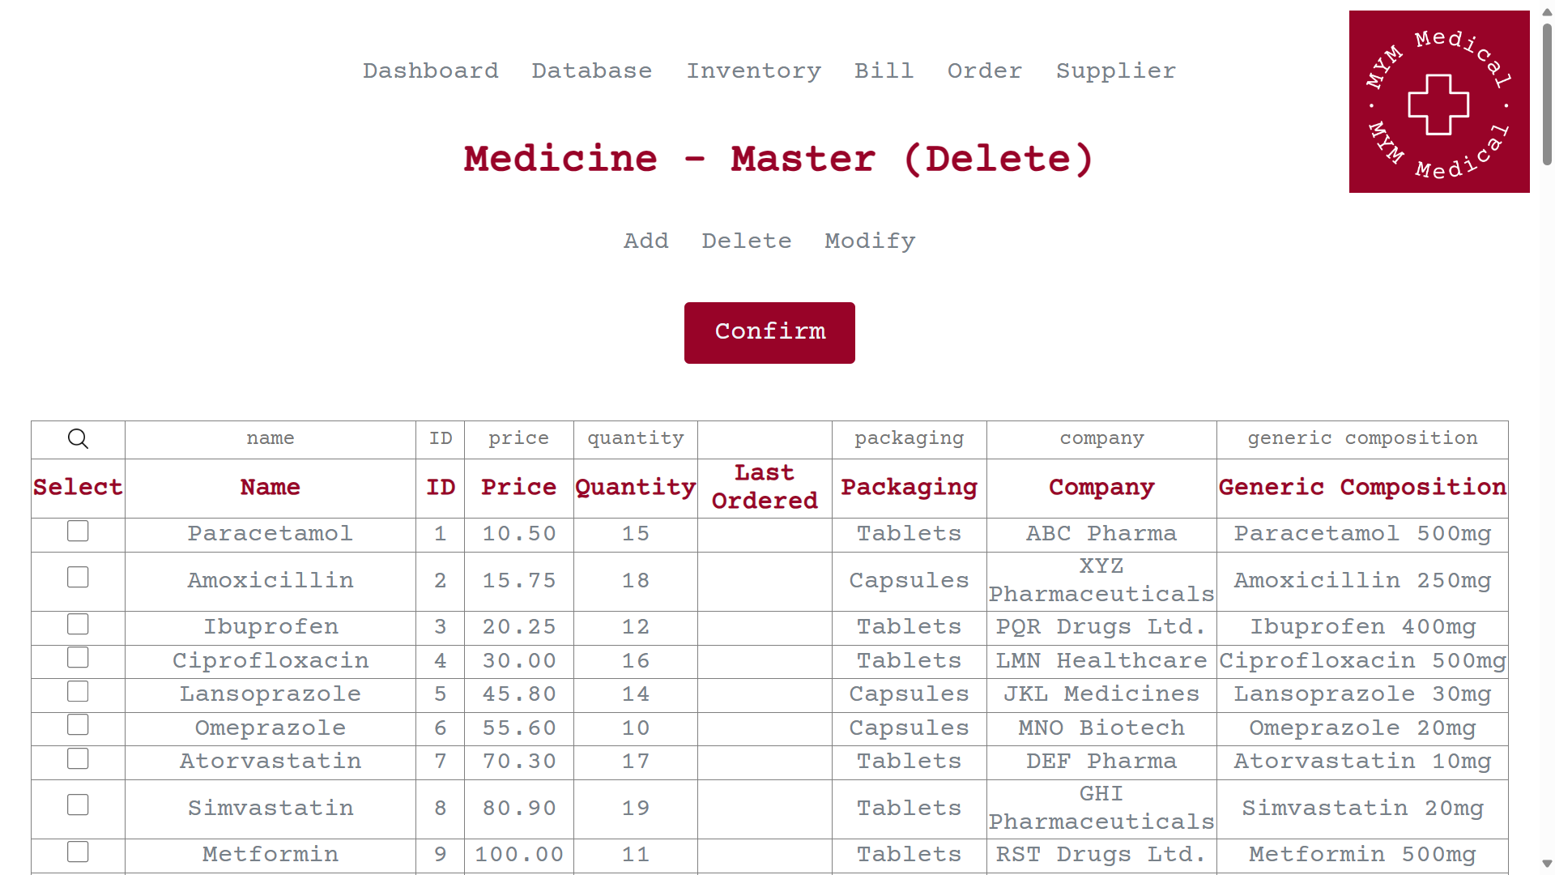

Fig 3.4.4.1.2 Table to choose any medicine to be deleted from the database.

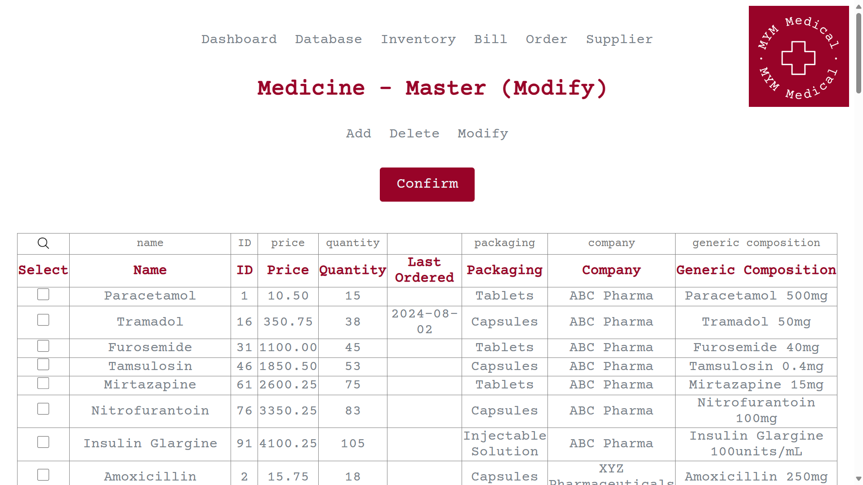

Fig 3.4.4.1.3.1 Table to choose any medicine to be modified in the database.

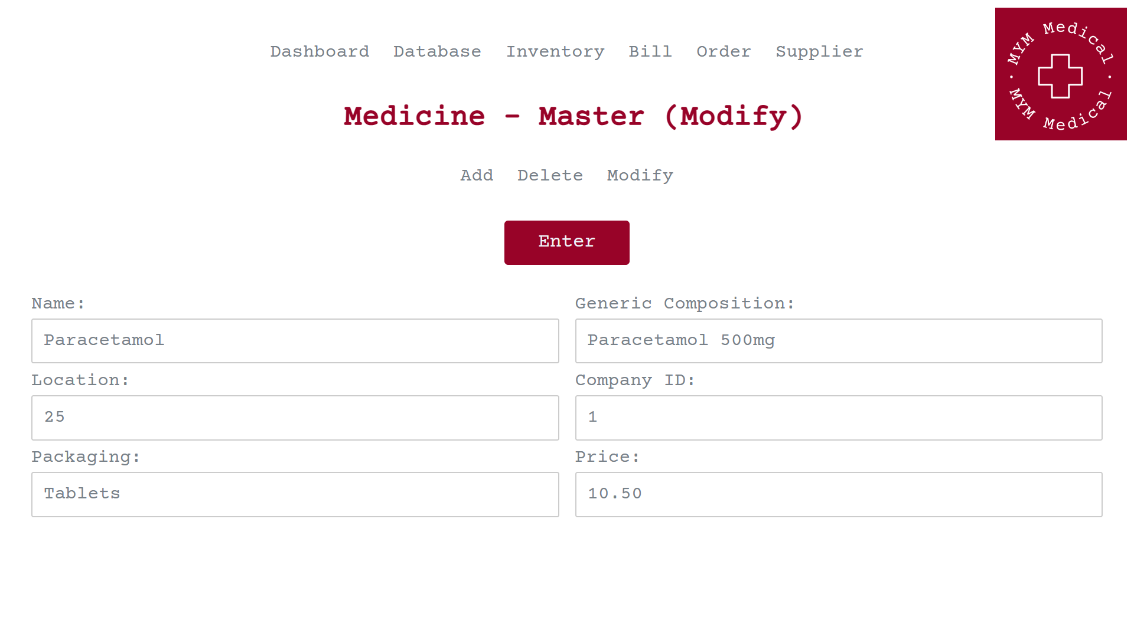

Fig 3.4.4.1.3.2 Form to modify any medicine.

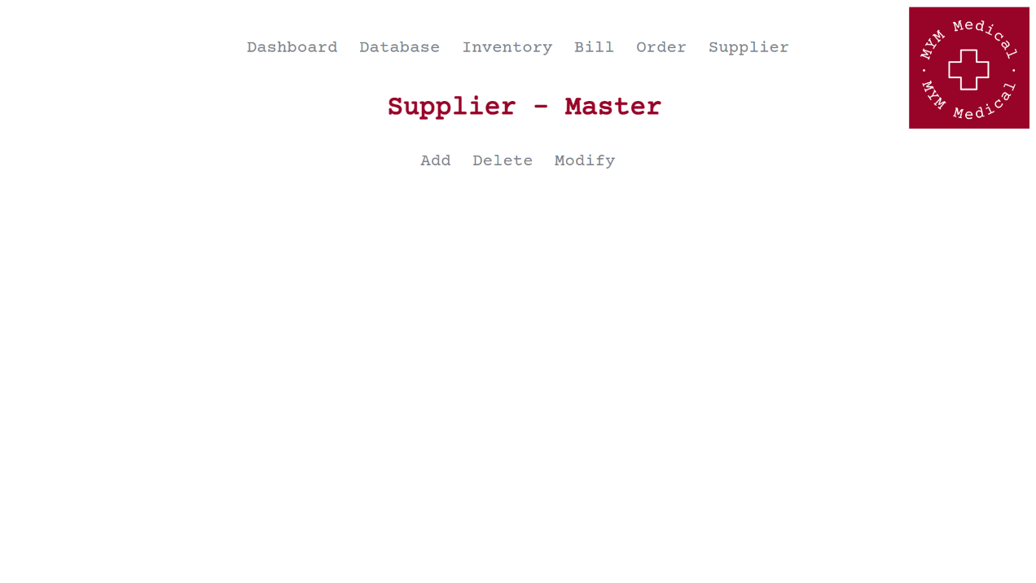

Fig 3.4.4.2 Supplier’s master.

Chapter 4: RESULTS AND ANALYSIS

4.1: FINAL RESULTS

Implemented Successfully.

Chapter 5: ADVANTAGES, LIMITATIONS AND APPLICATIONS
5.1: ADVANTAGES
The website offers a range of benefits that significantly improve the management of medicine inventory, supplier relationships, and order processing. Here are some of the key advantages:

- Comprehensive Solution for Medical Stores: Acting as a comprehensive platform, the website provides all essential functions necessary for effectively managing the supply chain of a medical store. It offers a holistic solution to address various operational requirements.

- Efficient Inventory Management: The platform offers a centralized system for managing medicine inventory. Users can easily add, remove, or update medicines, monitor quantities, and track stock levels in real-time, leading to streamlined inventory management.

- Improved Supplier Management: Users can efficiently handle supplier information, including adding new suppliers, updating contact details, and tracking supplier orders. This facilitates smooth communication and collaboration with suppliers.

- Simplified Order Processing: The website simplifies the order processing procedure, allowing users to view, track, and manage orders from suppliers effectively. Users can update order statuses, manage delivery details, and streamline the procurement process.

- User-Friendly Interface: With its user-friendly interface and intuitive navigation, the website ensures a seamless user experience. This makes it effortless for users to access and utilize various features and functionalities.

- Search and Sorting Functionality: Incorporating search and sorting functionality enables users to quickly locate specific medicines, suppliers, or orders based on various criteria such as name, ID, price, and quantity. This enhances data retrieval efficiency.

By capitalizing on these advantages, the website empowers users to efficiently manage their medicine inventory, optimize supplier relationships, and enhance the order processing workflow. Ultimately, this contributes to increased productivity and profitability for medical stores.

5.2: LIMITATIONS
Despite the numerous advantages it offers, the website also comes with certain limitations that warrant consideration:
- Business Logic Constraints: It's essential to note that the website may not fully accommodate complex business logics and regulatory requirements, such as Harmonized System of Nomenclature (HSN) codes, Goods and Services Tax Identification Number (GSTIN), GST input and output calculations, and legal discounts as per regulations.

- Single-Store and Single-User Limitation: The application is primarily designed for a single-store environment, which may limit its suitability for businesses with multiple branches or distributed operations. For enterprises requiring centralized inventory management across multiple locations and users, alternative solutions may be more appropriate.

- Technical Dependencies: The website's functionality and performance could be influenced by external factors such as internet connectivity, server reliability, and compatibility with web browsers and devices. These dependencies may impact user experience and accessibility.

- Scalability Challenges: While the website is well-suited for small to medium-sized businesses, it may encounter scalability challenges when handling large volumes of data, high transaction volumes, or rapid business growth. Addressing these challenges may necessitate infrastructure upgrades or software enhancements.

- Limited Feature Set: It's worth mentioning that the website may lack certain advanced features and integrations commonly found in enterprise-level inventory management systems. This limitation could restrict its capability to meet the evolving needs of larger or more complex organizations.

By acknowledging these limitations and carefully considering them in the decision-making process, businesses can make informed choices regarding the suitability of the website for their specific requirements and circumstances.
5.3: APPLICATIONS
The website application is most suitable for small to medium-sized businesses, particularly for single-store pharmacies or medical stores. Here are some of its key applications:

- Independent Pharmacies: Single-store pharmacies and independent pharmacists can benefit from the website by streamlining their inventory management processes, effectively managing supplier relationships, and efficiently processing orders. This leads to improved operational efficiency and enhanced customer service.

- Medical Stores: Independent medical stores and retailers can utilize the website to manage their medicine inventory, monitor stock levels, and coordinate with suppliers for timely replenishment. This ensures the availability of medicines and medical supplies to meet customer demand effectively.

- Startups and Entrepreneurial Ventures: Startups or entrepreneurial ventures in the healthcare sector, including online pharmacies, can leverage the website as a cost-effective solution for managing inventory and supply chain operations during the early stages of business development.

While the website's application may be limited to businesses with single-store operations, it serves as a valuable tool for optimizing inventory management, improving operational efficiency, and supporting the delivery of quality healthcare services to patients and customers.
CONCLUSION AND FUTURE SCOPE
In summary, the development of this medicine inventory management website marks a significant leap forward in transforming the operational landscape of medical stores. By providing a centralized platform meticulously designed to manage inventory, suppliers, and orders, the website equips users with essential tools to enhance efficiency and productivity in their daily operations. With its user-friendly interface, customizable features, it serves as a comprehensive solution tailored to meet the diverse needs of medical store supply chains.

FUTURE SCOPE:

Looking ahead, there are ample opportunities for further enhancing and expanding the functionality and user experience of the website. Future iterations could explore the integration of cutting-edge features such as predictive analytics for inventory forecasting, automated replenishment mechanisms based on demand analytics, and advanced reporting modules to provide stakeholders with actionable insights. Additionally, potential integrations with external systems like accounting software and e-commerce platforms could open up new avenues for seamless business operations and market expansion.

Furthermore, ongoing iterations and optimizations will be crucial in ensuring the website remains adaptable to emerging industry trends and evolving user needs. This approach will help sustain its relevance and effectiveness in the dynamic landscape of medical supply chain management.
REFERENCES

